

Equipment Inspection - Notes for Competitors

A team of official measurers representing different NCAs will be available prior to the start of this event to check your equipment for compliance with the IOM Class Rules (CR), IRSA Supplemental Class Rules (IRSA SCR) and the RRS. In order that this extensive process can be as smooth as possible, please prepare yourself as the best you possibly can. An equipment inspection shall be carried out prior to racing in this event, so it will be important that your boat is properly prepared to avoid unnecessary delays during the inspection. Please get your boat inspected AS SOON AS you are able and preferably before you launch your boat.

Tips to help with compliance

- Valid Boat Certificate
- Sail Number conflicts - Double check official entry list.
- Compliant spacing between adjacent digits of sail numbers as RRS E.8 (see diagram below)
- Please FILL IN any voids left from your number template. You will be asked to correct this and return if this is not complied with upon inspection.
- Sufficient contrast between color of sail number and sail to satisfy legibility per IRSA SCR C.11.2
- Deck limit mark on center plane per CR D.1.5 and hull identification per CR D.1.4
- ‘Correct’ corrector weights are to be fixed per CR C.4.3

*** Entering a boat known not to measure is a serious matter. ***

Sail identification

The readability of sail numbers is very important in radio racing because you cannot communicate with skippers to minimize the risk of collisions etc. if you cannot read the sail numbers at a distance. Unlike big boats, we have two large numbers (and 1 prefix to avoid conflicts). We must make them as clearly readable as possible. The RRS App G is changed by radio racing App E8. Please follow the full picture in the diagram below. (See App E.8 and E.8 changes to G1.6 for exceptions to these requirements for small sails.)

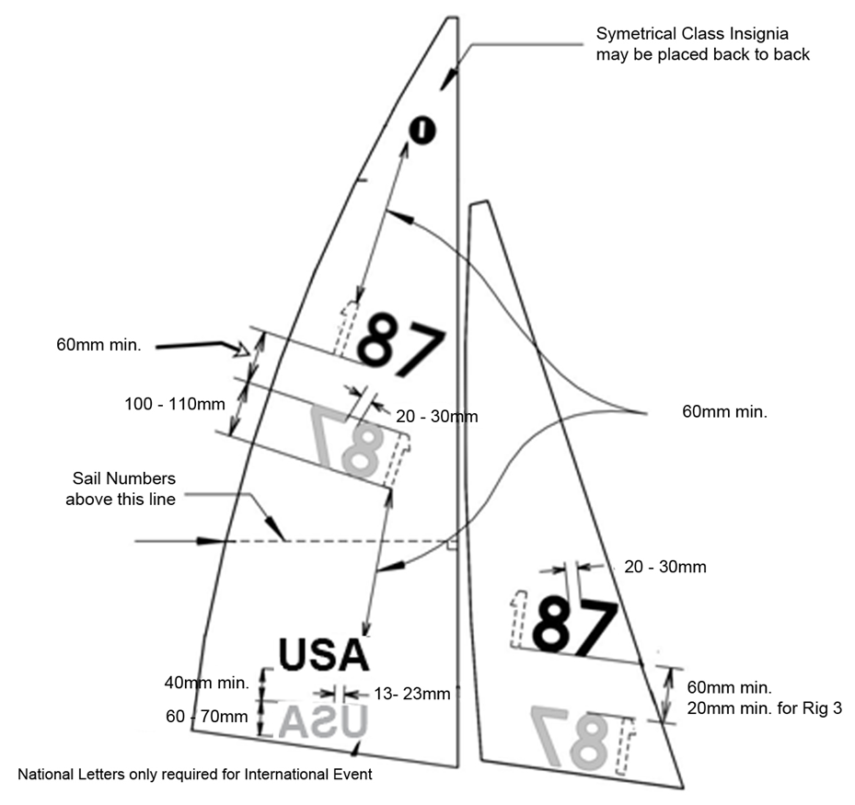
40mm min.
40mm min.
20mm min. for Rig 3
40mm min.

